**Brooklyn torah gazette**

**For parshas nitzavim 5781**

Volume 5, Issue 55 (Whole Number 255) 27 Elul 5781/ September 4, 2021

**Printed L’illuy nishmas Nechama bas R’ Noach, a”h**

For a free subscription, please forward your request to [***keren18@juno.com***](mailto:keren18@juno.com)

**Connecting with Our**

**Fellow Jews for a**

**Successful New Year**

**By Daniel Keren**

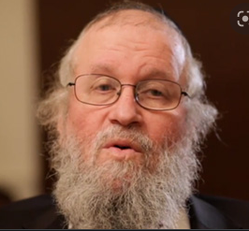

**Rabbi Elya Brudny**

The annual Hakhel Labor Day Yarchei Kallah was this year moved up early to this past Sunday insofar as this year the popular legal holiday falls Eruv Rosh Hashanah and many of those who regularly come to the Hakhel Events would have to miss out because of traveling out of town to spend the Yom Tov with their families.

The Pre-Labor Day Hakhel Event also served as the 32nd Nationwide Yom Iyun of the Agudath Israel of America and was livestreamed across North America and indeed the world. The theme of Sunday’s Yom Iyun was “Bain Adam L’Chaveiro (Between Man and His Fellow Jew”) Ad She’Yirtzah es Chaveiru (Until You Want for Your Friend what You Have.”)

One of the featured speakers at the Flatbush Pre-Labor Hakhel – Agudath Israel Yom Iyun Even was Rabbi Elya Brudny, Rosh Yeshiva of Yeshivas Mir Flatbush and Chaver (Member) of the Moetzes Gedolei Hatorah).

**A Common Theme with Both Rosh**

**Hashanah and Yom Kippur**

On the theme of the Yom Iyun concerning our Adam Lechavero (our behavior to fellow Jews), Rabbi Brudny focused on the connection of this important Torah concept to both the holy days of Rosh Hashanah and Yom Kippur. Beginning with the Day of Atonement, Rabbi Brudny explained that Yom Kippur is a dual avoda (spiritual service) with one striving to do teshuvah (return to Hashem by promising to improve our Torah observance) but just as importantly making the commitment to repair our ties with our fellow Jews.

Indeed at the beginning of the Yom Kippur davening at night the congregation is reminded by the rabbi to forgive other Jews who may have harmed us or offended us.

Rosh Hashanah, Rabbi Brudny explained, is different from Yom Kippur in that the focus is not on teshuva, but rather on proclaiming the malchus (the kingship of G-d) over us as a Jewish nation and over each and every one of us as individuals in Klal Yisroel. The ultimate goal of Rosh Hashanah is to submit and surrender ourselves to Hashem by establishing malchus shomayim (His heavenly rulership) over us for the coming year.

**We Must Be in Harmony with Our Fellow Jews**

Yet in order to be truly in submission to Hakodesh Baruch Hu (the Holy One blessed be He), we have be together in harmony with our fellow Jews. How can we truly be serving Hakodesh Baruch Hu as our King if we are not in peace with Hashem’s other subjects. The avoda (spiritual service) of Rosh Hashanah is to make Hashem our melech (king.)

If one is not in shalom with other members of his or her family, chaverim, etc. he cannot be a perfect subject of Hashem who wants all His subjects to be living in gentle harmony [like a father who wants his children to be at peace with each other.]

To understand this we should study the story about Hillel Hanasi to whom a goy (non-Jew) came and said that he wanted to convert to Judaism, but before that he insisted on being taught the entire Torah while standing on just one foot (indicating that he wanted to be given a quick lesson.) This same goy had first gone to Shammai the other leading Torah leader of that generation who was so offended by the non-Jew’s chutzpah that he grabbed his stick to chase him away. Hillel however agreed to the goy’s request and declared as recorded in Mesechta (the Talmudical tractate of) Shabbos (31a): “What is hateful to you, do not do to your fellow: this the whole Torah, the rest is the explanation, go and learn.”

**The Focus is that Hakodesh Baruch Hu**

**Is Each and Everyone’s Best Friend**

Rabbi Brudny explained that on Rosh Hashanah we should focus on the concept that Hakodesh Baruch Hu is each and everybody’s best friend. How can you go against His wishes? If you want to have a relationship of “re’eicha kimocha – love your friend as yourself” with Hashem, you have to first have a “re’eicha kimocha” relationship with your parents, your siblings, your spouse, your neighbors, your colleagues at work or in shul, etc.

The path to an elevated relationship with Hakodesh Baruch Hu is to first have a down-to-earth relationship with another human being. The playground to achieve this goal is to develop and internalize the lofty concept of hakoras hatov (gratitude) for another human being.

Without the appreciation for the good you have benefitted from other human beings, you can never understand the ultimate good that Hakodesh Baruch Hu is bestowing upon you [at every moment of your life.] Do you recognize the many benefactors around you? Do we really make the important effort to internalize and appreciate the good we have from others around us?

**A Stepping Stone to Connecting**

**To Our Avinu Bi’Shamayim**

In this respect, Rabbi Brudny explained that Adam Li’chavero is the stepping stone to connecting with our Avinu bi’shamayim (our Father in heaven). If you don’t have the ability to compromise your desires with another person because of their needs, you can’t ever hope to do the same with Hakodesh Baruch Hu.

Wishing all the readers of The Jewish Connection and Klal Yisroel a chasima v’chasiva tova with the coming of Moshiach Tzidkeinu in the coming year if not before.

*Reprinted from this week’s issue of The Jewish Connection.*

**Parshas Nisavim:**

**A Glimpse into the**

**Upper Worlds**

**By Rabbi Bentzion Shafier**

**Founder of TheSmuz.com**

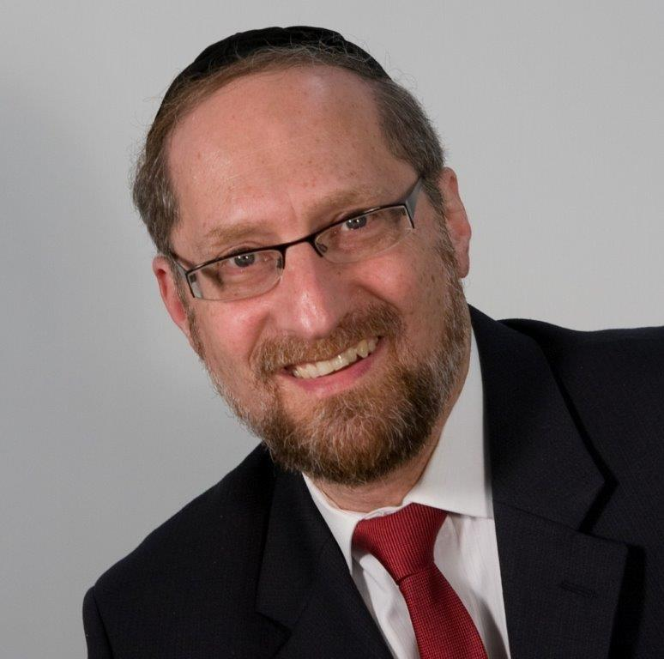

“*I appoint, today, as your witnesses the heavens and the earth…”* Devarim 30:19

On his last day of life, Moshe Rabbeinu addresses the Klal Yisrael. After a thorough explanation of the vast rewards and ghastly punishments that hinge on the choices made, he offers a final note: Let the heavens and the earth bear witness.

Rashi explains that Moshe was giving them a tool to help them stay on the proper path. “Look at the heavens and the earth did they change their ways? Did the sun ever say, ‘I won’t rise this morning?’ Did the ground ever say, ‘I won’t produce?’ Or did it say, ‘I will grow wheat instead,” when you planted barley? As they dutifully follow Hashem’s commands, so too should you.”

**Question:**

What possible lesson can we learn from the sun and the earth? Of course they follow Hashem’s commands, they are inanimate—they have no intelligence, they have no will, they have no competing desires. They obey because they are objects put into motion. What relevance does that have to man who is always tempted, always pulled, always challenged with choosing between the voices inside of him?

This question can best be answered from a different perspective.

In our modern world we regularly harness forces that our eyes don’t see. No human has ever seen electricity. We can see the burning of impurities in the air as lightening streaks across the sky. But the flow of electric current is not visible. The transducer in our microwave emits tiny waves, causing the electrons to speed up, thereby creating friction that heats our food.

We power up a cell phone that emits waves to a tower far away, that then relays signals to a satellite three miles up in the sky, then sends them across the world. We turn on our GPS, and instantly triangulate signals sent from the sky. Our laptops are wireless, our garage openers are remote, and the idea of powering a city on the energy released from the atom is something we are comfortable with. We are quite comfortable operating in a world that is naked to the human eye. Yet we are fully aware that it exists.

We don’t see radio waves. We don’t see Wi-fi. We don’t see electron. But they exist. And we know it.

These concepts aren’t far off theories—they are real.

If I were to offer you twenty dollars to a key into a wall socket. I doubt you would accept my offer. For while you may never have seen the flow of electricity, you are quite certain that this will end badly.

While we are sophisticated in that manner, we remain ignorant of others. The Rambam tells us that every physical entity, live or inanimate, has a spiritual entity guiding it, directing it. Chazal tell us that no blade of grass can grow without a *moloch* telling it to grow.

**Relating to the Dor De’ah**

This seems to be the answer to this Rashi. The Jewish People then were on the highest spiritual level of any generation. They experienced all of the miracles in *mitzraim*. They lived through the splitting of the sea. They were there at the foot of Har Sinai, when Hashem spoke. The heavens were opened up and they witnessed things that no other people saw.

And so they had an understanding of the ways of the world that we don’t. As we know electricity exists, they knew the spiritual counterpart exists. To them it was real.

And so Hashem said to them, “Look at the sun,” it is guided by an intelligent spiritual force. That force is an *independent* entity– it has its own will – and so, it could choose to disregard My directives. But it doesn’t. It recognizes that every command I give is for the good. So it obeys. As do all of the forces that guide the physical world. Not because they have to, but because they understand. So to should you understand that every mitzvah helps you grow, and every sin damages you. Learn from the wisdom of the sun and the earth, and don’t veer off the path that I have set for you.

**Man’s Position in the Cosmos**

This concept is relevant to us in the sense that every once in a while it is important to move out of our limited perspective, and look at the vastness and complexity of this world. Whatever our physical senses perceive, is but the tip of the iceberg, the spiritual world is far more densely populated, and far more complex. There are worlds and worlds in the spiritual dimension—and all of it is dependent upon man.

“On Rosh HaShanah the angels tremble.” (Rosh HaShana 17a) Why?

Hashem made the heavens and the earth for man. But it wasn’t just the physical. Hashem Created man in His image. Hashem made man is a little creator. There are worlds that are dependent upon on him. His choices either elevate those worlds, or destroy them. He is the pivot of existence. If he acts as he should, the world itself is elevated. If not, the world itself is damaged.

Man is the steward to creation. He is responsible for the world status and existence. But not in the mundane sense of the ground and the rivers, a glorified park ranger.

Man is the pivot of all existence. If we act as we should, the world itself is elevated, if not, the world itself is damaged. It doesn’t mean the ground is less ground like, it doesn’t mean the mountains aren’t as tall. The spiritual component of the ground, the spiritual backing of the mountain is lessened. .

U’ Molochim Yeichafuzun, and the molochim shudder.

**Man is the Steward to Creation**

Hashem created man and made him steward to Creation.. Hashem made man

Chazal tell us that on Rosh Hashana, when Hashem judges the world the molochim tremble. They tremble because their existence is being decided. If man As man goes, so goes the world.

If we were aware of our importance and significance, we would have a very different perspective on the importance of our toughts, words and actions.

We would recognize the entire world is dependent upon us.

*Reprinted from the current website of TheShmuz.com*

**Saving Him from Cremation, A**

**Jew in Vietnam Brought to**

**Kever Yisrael by ZAKA & Chabad**



**Photo: ZAKA spokesperson**

An Israeli Jew who was in Vietnam for business purposes contracted the coronavirus a little over a week ago and quickly deteriorated, passing away on Shabbos at the age of 51.

In accordance with Vietnamese law requiring all coronavirus fatalities to be cremated, the authorities were not planning on releasing his body for burial. However, the Chabad shaliach in Vietnam, Reb Menachem Hartman, intervened and an international effort to save the niftar from cremation was launched.

“In a race against the clock, we succeeded in releasing the body of the niftar from the hospital and obtained a cremation waiver,” said Reb Hartman.

Yossi Landau, a ZAKA International volunteer, said that ZAKA went into action upon receiving the report on Motzei Shabbos. Together with the Israeli Foreign Ministry and Chabad shlichim around the world, they first made efforts to bring the niftar to kevura in Israel but “due to the opposition of the Vietnamese authorities, we had to temporarily bury him in Vietnam.”

“We sent tachrichim from Hong Kong and with a special minyan we held on Zoom with ZAKA volunteers, Chabad shlichim worldwide and the niftar’s relatives, we succeeded in bringing the niftar to kevurah and preventing a serious desecration of kevod hameis.”

Rav Yaakov Rosa, the head of ZAKA’s Rabbinical Vaad, instructed Reb Hartman how to prepare the kever and carry out the kevurah with full protective clothing and in accordance with strict Vietnamese regulations.

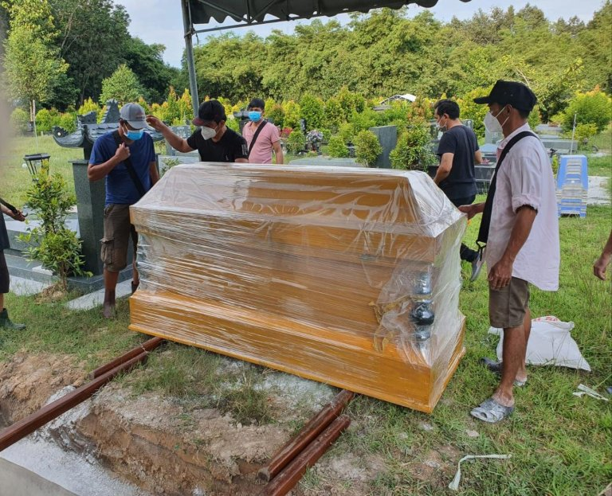

**Photo: ZAKA spokesperson**

Reb Hartman, accompanied by Vietnamese government officials, buried the niftar in a local cemetery in the hope of reburying him in Israel when pandemic conditions allow it.

*Reprinted from the August 16, 2021 website of Yeshiva World News.*

**Rabbi Berel Wein on**

**Parshat Ki Tavo**

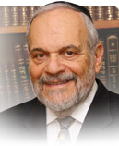

Towards the conclusion of his long final oration to the Jewish people, our teacher Moshe refers once more to the covenant between G-d and Israel. A covenant is much more than a relationship or an agreement. Covenants, in the Jewish sense of the word, are not altered by changing times and differing circumstances. A covenant has the ring of eternity, not only in time but also in content.

Covenants are immutable and unchangeable. They have a binding quality that ordinary agreements or even contracts do not possess. And this is true from the beginning of the story of the Jewish people, and maybe even from the beginning of history and G-d's relationship to human beings as Creator. We find in the story of the flood and the rainbow, that the relationship is always based on a binding and unchangeable covenant.

The Jewish people have always sensed the gravity of the covenantal relationship with G-d. It is the sole explanation for all the events and patterns of Jewish history from the time of Abraham until today. We are a covenantal people and are bound by restrictions and fueled by prophetic vision and utopian hope.

Only a people who feel themselves part of and bound by an eternal covenant, would have the strength and the ability to survive and even prosper under the circumstances of persecution and enmity that have surrounded the Jewish world from time immemorial. It is no cause for wonder why the circumcision ceremony in Jewish life is always called the covenant, for it represents in a physical manifestation, this binding covenant between G-d and the Jewish people.

It is well understood why Moshe fills this final oration to the Jewish people with references and lessons, explicit and implicit, to the covenant and to Sinai as the basis of Jewish existence. Only the power of a covenant is strong and mighty enough to guarantee the survival and resilience of the Jewish people. But the shepherd knows very well the weaknesses and strengths of his flock. The 40-year sojourn in the desert has been a learning experience for Moshe, and through his example, for all future leaders of the Jewish people in all times and under all circumstances.

The one thing that Moshe feels is deeply implanted within his people is this idea of a covenant. It is this covenant that creates within us the feeling of being special, chosen and bound by a mission that is far greater than the mundane activities of even life itself. The covenant contains many harsh conditions and predictions. It also portrays an exalted future and a continual message of productivity and influence that will permeate Jewish society. The vital behavior of the Jewish people, its ability to rise to all occasions, is based on our appreciation of the covenantal relationship between G-d and Israel. Individually, there are many Jews that may not feel bound or even be aware of the existence of this covenant. But within the Jewish soul, as part of our DNA so to speak, we know that we are a covenantal people, and we are charged to think and behave accordingly.

*Reprinted from the current website of rabbiwein.com*

**The Power of Jewish Unity and The Desire of G-d to Make a**

**Covenant on Rosh Hashana**

**From the Talks of the Lubavitcher Rebbe**

**Rabbi Menachem Mendel Schneerson, Zt”l**

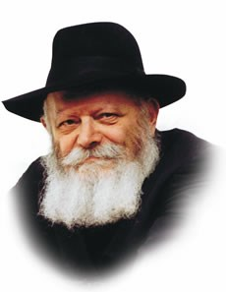

This week we read two Torah portions, Nitzavim and VaYeilech. The Torah portion of Nitzavim is always read on the Shabbat before Rosh Hashana. Indeed, its very first verse reveals its appropriateness: "You are standing this day, all of you, before the L-rd your G-d." "This day" refers to the Day of Judgment, Rosh Hashana.

On Rosh Hashana every soul, great and small alike, stands before G-d, as it states, "Your heads, your tribes, your elders and your officers...your little ones, your wives...from the hewer of wood to the drawer of water."

Why do we stand before G-d? "So that you may enter the covenant of the L-rd your G-d." When all Jews stand before Him as a complete and unified entity, we become worthy of entering into His covenant on Rosh Hashana.

A covenant is designed to preserve the feeling of love that exists between two people. They establish a covenant at a time when their love is strongest, so that it will never weaken. This bond connects them to each other and ensures that their love will last forever.

So too is it with G-d's love for the Jewish people. His love for us is strongest on Rosh Hashana, as the previous month was devoted to removing our sins.

But how do we arouse G-d's desire to establish a covenant with us? By being united with one another. How are we to accomplish this, given the differences between individuals? This can be understood by the following analogy:

The human body is composed of many different limbs and organs. Some are more important, like the head; others are simpler, like the foot. But the head, no matter how important, needs the feet in order to move. The body achieves perfection only when all its limbs act in harmony.

In the same way, even the most important Jews ("your heads") require the simplest ones ("the drawer of water") in order to comprise a complete entity. And it is this unity that arouses G-d's desire to make a covenant with His people.

Our job is to achieve this unity between "head" and "foot." Every Jew must work on himself until he can recognize his fellow's unique qualities. It is beyond our capacity to judge a person's true worth. Even if one considers himself a "head" and the other fellow a "foot" (as it is human nature to inflate our own self-worth), the "head" still needs the "foot" in order to comprise a complete being.

Let us concern ourselves with correcting our own flaws and not heed the perceived flaws of others. Doing so will ensure that there is no time to look at others' imperfections!

In this manner we will achieve both self-perfection and perfection as a nation, and G-d will grant the entire Jewish people a good and sweet year.

*Reprinted from the 5756/1996 Parshat Nitzavim-Vayeilech edition of L’Chaim Weekly. Adapted from the works of the Lubavitcher Rebbe.- Likutei Sichot, vol. 2*

# Rav Avigdor Miller

# On Frum Crooks



**QUESTION:** **Is it possible that an Orthodox Jew who is unscrupulous in business is worse than a Jew who doesn’t observe mitzvos but at least he’s decent?**

**ANSWER:** Oh, I see. It’s the same old red herring question. The old red herring about people with beards who steal being worse than the irreligious who are always tzadikim gemurim.

He’s asking me if an unscrupulous Orthodox Jew is as good as an honest unorthodox Jew.  But let’s ask the question this way: Is the unscrupulous unorthodox Jew as good as a scrupulous Orthodox Jew? Because really, that’s how it is.

Let me tell you a little story. There was a time when I used to take a taxi every day. I had to go from one school to another to talk and I used the same driver every day; he was an old American Jew, an eighty-year-old man. He didn’t know how to learn a thing. He didn’t even know siddur; he knew nothing. But one thing he did know. He knew that the Orthodox Jews are no good.

He was describing to me how his daughter was married. He had an old daughter who finally got married and he hired a chazenta to put on a tallis and a yarmulke and she sang “Oh Promise Me,” –  a big fat chazenta singing her heart out. When I smiled at that, he said, “You Orthodox Jews don’t have any beauty in your ceremonies.”  Finally we crossed the Parkway and we came into Flatbush; there was a long way to go yet but he closed down his meter. I said, “Why are you closing the meter?” So he tells me “Because my boss earned enough today. The rest of the fare will go to me.”

Now, he didn’t even dream that he was a crook. And that’s how it is – the unorthodox don’t even know that they’re crooks. All they know is that the Orthodox are crooks. By virtue of being Orthodox, you’re already a crook.

And therefore, certainly it’s wrong to be a crook. And it’s wrong to be unorthodox. It’s wrong to be every bad thing. But let’s use our own judgment and ask who is more liable to be a crook? Who is more likely to be a crook? A man who studies his whole life the dinim of somebody else’s money or someone who never opened the Gemara?

An Orthodox Jew learned Bava Kama when he was a boy in the yeshiva. He learned that you can’t take somebody’s money. He learned about gezel ha’ger. He learned that if you swear falsely you have to bring a kaparah. You had to bring an asham and the keren and a chomesh. It’s a big job. And suppose that the man you wronged went to Madai, to a faraway place? So you have to go after him all the way to Madai. It’s a big job to return money you stole. Because there’s a very big responsibility once you take somebody’s property. That’s what it is if you know Torah.

But an unorthodox Jew?  People take it for granted that from the atmosphere he absorbed all the laws of decency and all the ideals of justice and righteousness. All good things he learned from the TV and the movies. That’s as cockeyed as can be! Because the unorthodox, they’re the ones who are really crooks. I’m not saying all of them. But if there’s a possibility of crookedness, they’re the ones.

I’ll explain this. Let’s imagine it’s Yom Kippur and let’s say you have an intermission in your shul. They daven a fast mussaf you have a lot of time before mincha. So you take a little walk on Ocean Parkway and you now you pass by the Mirrer Yeshiva. The door is open because it’s hot and they’re busy davening. Everybody is weeping. They’re shouting and weeping. “What are they weeping for?” you ask. You think that maybe somebody important just died.  So a boy who’s near the door tells you that they’re weeping for their sins. They’re weeping for their sins! It means that the Mirrer Yeshiva is full of sinners.

So now you walk further down, way down to the other side, and you come to a big Jewish center and you’re curious. You stick your head in and people are smiling. Everybody there is happy. Nobody is weeping on Yom Kippur. There’s no sin in that Conservative Jewish Center.

Why is it that in the conservative place there are no sins? The answer is, listen to the following words: When you have a good conscience it’s a sign of a poor memory. The Orthodox Jew says, “Let us search out our ways; let’s investigate.” And he does searching. He learned what’s wrong and sometimes he even thinks about it too.

But if you never learned then you think you’re a tzadik. Where did you learn it’s wrong to steal? Just by chewing gum and playing baseball? How do you pick up the ideal of regarding the other man’s property as sacred? You’ll never hear it!  So you must realize that this question is a red herring question.  
TAPE # 204 (February 1978)

*Reprinted from the August 9, 2021 email of Toras Avigdor (Tape #204 – February 1978.)*

**Thoughts that Count**

Rabbi Meir said: "Whoever occupies himself with the study of Torah for its own sake--lishma--merits many things; and not only that, but the entire world is worthwhile because of him." (Ethics 6:1)

The word "lishma" literally means "to its name." Torah's name, stemming from the root hora--instruction, signifies "teaching." Study Torah that it may teach you. Open your heart and mind to its inspiration. Let it form the pattern of your life. *(Rabbi I. Bunim in Ethics from Sinai)*

Ten things were created on the eve of Shabbat at twilight: 1) the mouth of the earth [that swallowed Korach]; 2) the mouth of the well [that supplied water to the Jews in the desert; 3) the mouth of the donkey; 4) the rainbow; 5) the manna; 6) the rod [of Aaron]; 7) the shamir [worm]; 8) the writing script [of the Ten Commandments]; 9) the manner of writing; and 10) the tablets of the Commandments... (Ethics 5:8)

The Oral Torah relates that every kind of taste could be discerned in the manna. If someone wanted to enjoy a specific food, so did his manna taste, even if he said not a word but only thought his wish. It was completely digested and absorbed, leaving no waste matter to be evacuated. They could eat it all day if they wished -- it would not harm them. Righteous people found their manna easily at their doorsteps; those not so virtuous had to go out a bit to gather their measures; and the downright wicked had to search far afield for their quotas.

Rabbi Yehoshua ben Levi said: "Each and every day a Heavenly Voice goes forth from Mount Choreb..." (Ethics 6:2)

Our souls exist on several planes simultaneously. This Heavenly Voice reverberates, and is "heard" by our souls as they exist in the spiritual realms. And this causes our souls as they are enclothed within our bodies to be aroused to teshuva-repentance. *(Likutei Sichot, vol. 9)*

*Reprinted from the 5756/1996 Parshat Nitzavim-Vayeilech edition of L’Chaim Weekly.*